The Organic Star

E-Project

Design Guide

Group Members

**Group:** ?

**Curriculum:** 7062

**Semester:** CPISM

**Supervisor:** Sir Shahryar



|  |  |
| --- | --- |
| Enrollment ID | Name |
| Student 1414768 | Sarim Ur Rehman |
| Student 1417791 | Sadat Muhammad Khan |
| Student 1414771 | Muhammad Huzaifa |
| Student 1414766 | Muhammad Umama |

**Synopsis**

The static website is dedicated to showcasing a wide variety of high-quality food products from various categories. The website boasts an impressive collection of nutritious cereals, pulses, spices, condiments, cooking oils, fruit pulps, agro products, oils, wheat and wheat flour, rice and rice products, and more.

The homepage greets visitors with a visually appealing layout that displays a range of product categories. Each category is represented with an image and a brief description of the products it contains.

Clicking on a particular category takes the user to a dedicated page that showcases a range of products available under that category. Each product is accompanied by a high-quality image, a brief description, and its price.

The website also has a search bar that enables users to search for specific products or browse products by keywords. Additionally, the website offers a convenient shopping cart and checkout system, making it easy for users to order and purchase products.

Overall, the website provides a user-friendly interface that is easy to navigate and showcases a diverse range of quality food products.

**Acknowledgements**

We would like to express our sincere gratitude to everyone who has contributed to the successful completion of this project.

Our heartfelt thanks go to **Sir Shahryar** for providing invaluable guidance and support throughout the entire process.

We are deeply grateful to our colleagues and team members for their hard work, dedication, and collaboration. Their efforts have been instrumental in bringing this project to fruition.

We would also like to thank our families for their love and support, which has allowed us to stay focused and motivated.

Finally, we extend our thanks to all those who have provided us with the resources and opportunities necessary to complete this project.

This project would not have been possible without the help and support of all of you.

**Thank you**.

Problem Statement

Star Organic farm is commenced in the year 1988. Company is involved in trading

and manufacturing a wide range of Organic Products and spices to the consumers all

around the global market. Company has wide variety of collection of products lies of

Nutritious cereals, Pulses, Spices and Condiments, Cooking Oils, Fruit Pulps,

Agro Products, Oils, Wheat and Wheat Flour, Rice and Rice products and so

on.

Requirement Specification:

The Web site is to be created based on the following requirements.

1) The Home Page should be created making use of Sections with a suitable logo

of STAR BRAND.

2) Links such as Home, Products, Contact Us, Query, Show case gallery must be

included.

3) The Products must be properly categorized and details of each product must

be presented with suitable size image.

4) For each information section of the products the enquiry and order link must

be provided.

5) Contact us page must be included.

6) Navigation must be made smoother.

7) Uniformity in the designing must be maintained in the application.

8) Images must be defined with alt attribute defined.

Nav Bar

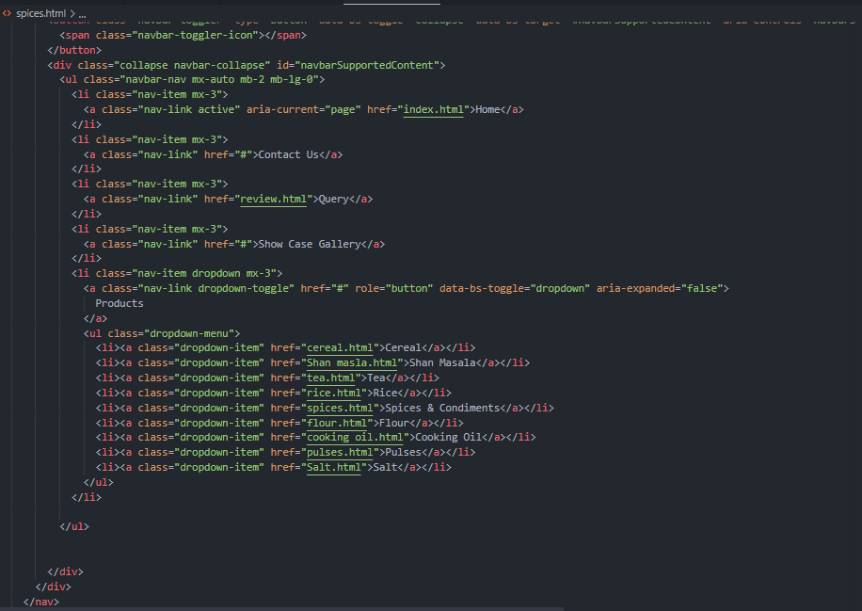



**Our Products**

Popular items

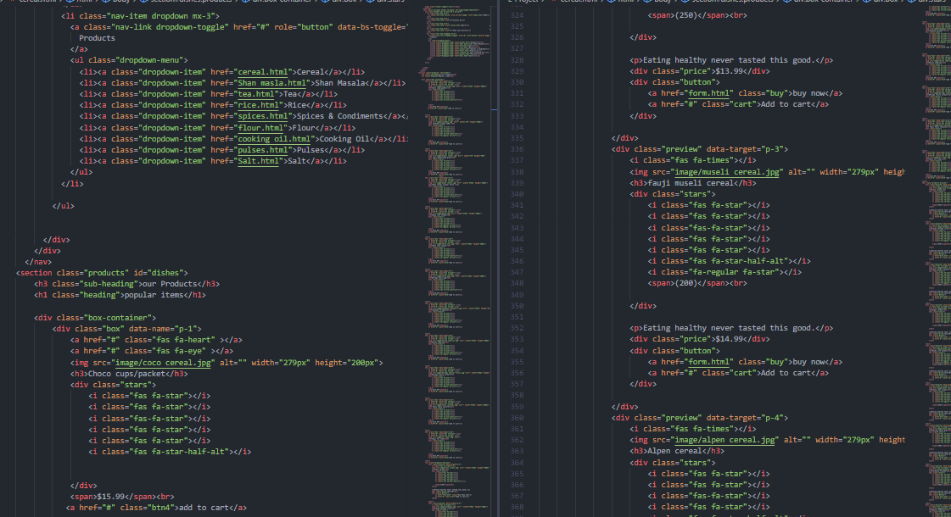

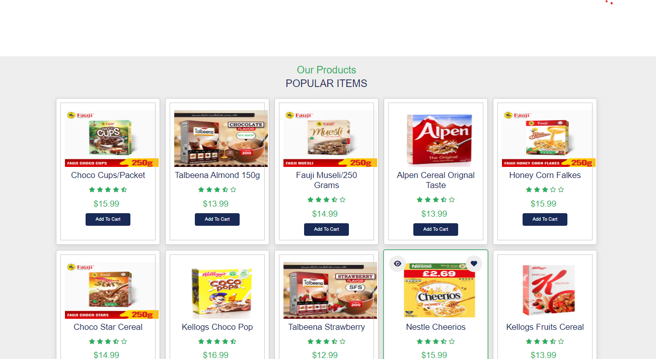

Contact Us

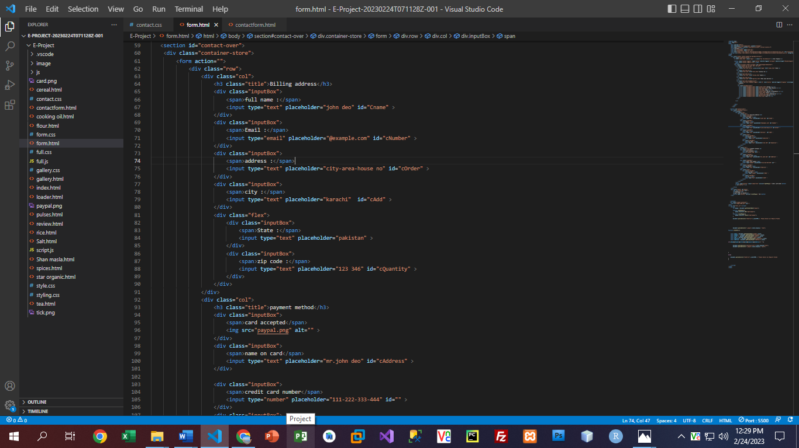

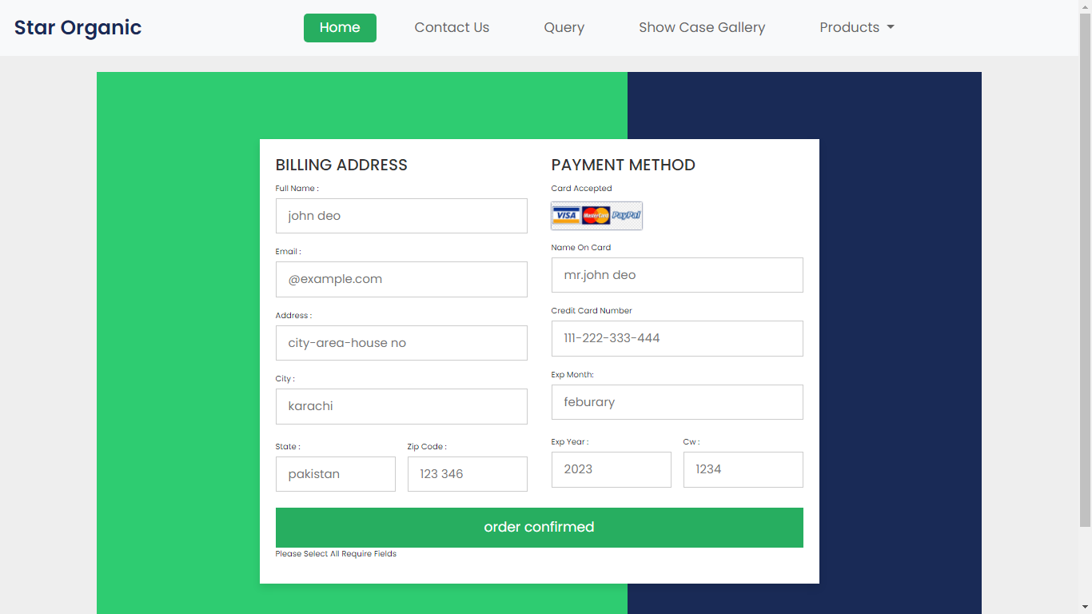

**Query**

### Customer's Review

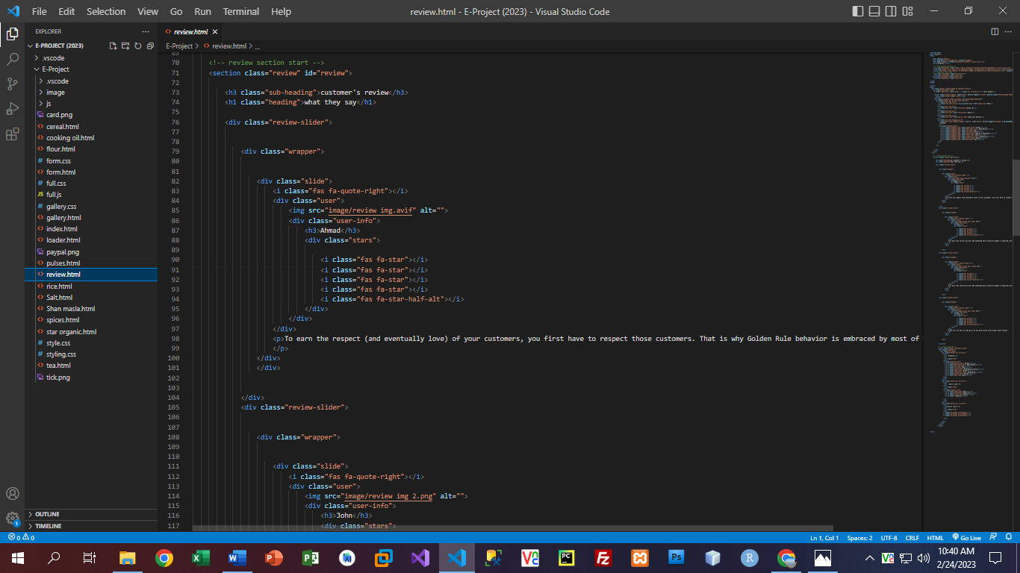

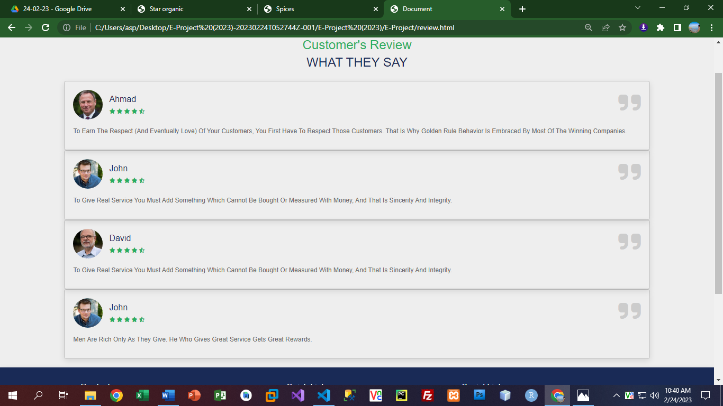

**Gallery**

